**NEWS-RECOMMENDATION SYSTEM**

**Introduction**

The constantly growing digital world is faced with a major problem of information overload, this is evidenced by the numerous articles that are made available on different news platforms hence making the target readers to have a difficult time finding the information they are in need of. We have developed the News Recommendation System that solves this problem through the provision of news that have been personalized on the preferences of the user at the same time reducing bias. This system has been built with Streammlit with interactive interfaces.

**Problem Description**

The current digital age is made up of a large volume of trending information that is made available to the users, these users are in return faced with a problem of finding the information that is relevant to them hence making it difficult for them to stay up to date with the current trends. The existing news platforms display information in a sequential manner based on the time presented, this makes some of them not to fit the interests of the user. These users are in turn faced with a difficult task of staying up to date with the needed information and this is because of the existing gap of personalizing how the information should be presented to them.

The other major issue is the rising concern of false information that has been biased during reporting. This is due to rise of the online interactive platforms, this makes it challenging for one to differentiate between fake and credible information. We therefore established that individuals are in need of a system that can provide recommendation of the news that interests them by filtering out information that might be fake hence misleading.

To add on this, we discovered that platforms that are currently in use do not have the intelligence to provide recommendations that can match the preference and habits of the user. This is due to a reliance on the manual methods which are static and outdated, this in return does not keep up with the changing habits attached to the user.

We have developed the News-Recommendation System in order to solve this problem, this system makes use of machine learning to analyze the habits of the user and provide a personalized news-experience. The system provides the user with a range of options they can choose from in order to have a good experience that satisfies their needs.

**Objectives**

To provide news recommendations with no bias and which are relevant to the preference of the user.

To leverage on the machine learning models in delivering news suggestions that are personalized.

**Research Questions**

The development of the system was guided by the following questions:

1. What will be the effective achievement of a recommendation system that is personalized through the algorithm that will filter out the preference of the user?
2. Which methods can be used to select credible information from the large pool of existing fake and misleading sources?
3. How will the system improve the satisfaction of the user by keeping them and engaged through the personalized feed?
4. What are the major problems in striking a balance between the delivery of content and personalizing the same?
5. What optimizations will be done through the various models of machine learning in having control over the large pool of data that is currently available?

**Methodology**

We have leveraged on a collection of machine learning techniques in order to deliver information that meets the personalized needs of the target user. The following key steps were followed in developing these:

1. Data Collection: The training data set used to develop the system was collected from <https://www.kaggle.com/datasets/arashnic/mind-news-dataset> website. This has made its collection from Microsoft website anonymized behavior logs.
2. User Profile: We have developed a section that allows the user to create their profiles, the user will be prompted to input their username, email, and password. This will help in keeping track of the user, and allow the user to be able to customize how the information that should be delivered to them.
3. Recommendation Algorithm: The implementation has been made based on a hybrid approach that brings together information that has been filtered through a suggestion of various areas of interest. The content is filtered in a collaborative manner that regroups similar information under specific categories.
4. Credibility: To ensure the credibility of information, we chose our training dataset from MIND: Microsoft News Recommendation Database that is known for its high reputation hence ensuring the accuracy of the content that will be delivered to the user.

**Evaluation Approach**

We placed the following evaluations on our proposed solution with regards to the problem area:

1. Accuracy: Accuracy was used in placing an establishment on how well the preference of the user have been matched by the recommended source. This has been implemented through the following ways: Cleaning text through the removal of punctuation and stop words, text was normalized, and repeating articles were removed to avoid recommendations that have been duplicated.

TF-IDF Vectorization was used to provide emphasis to those words that have been used in the context but are not so common, this has aided in differentiating content in a manner that is more accurate, for example the system gives low weight to the commonly used terms, highlights those terms which are more specific, and makes a customization on parameters like max_df, min_df, and ngram_range inorder to improve word selection by making it meaningful.

Cosine Similarity Matching was used to compare text regardless of the length by measuring the angle between vectors, and not their magnitude. This ensured accuracy by using semantics to match articles to the query of the user, preventing those results that share a few high-frequency words, and using vector space to rank articles by closeness.

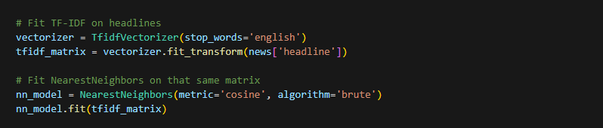

Filtering was done by setting a minimum cosine similarity score to assist in removing those articles that are loosely related, this will result in displaying the relevant results that have been sorted. Keywords have been used to highlight the results.

1. Precision: Precision was used in evaluating the need of the articles which have been recommended against their counterparts which have not met the same.
2. Credibility: Credibility was used in tracking and making checks on the selected sources for recommendation which are considered to be reputable. In this case our training data set was obtained from <https://www.kaggle.com/datasets/arashnic/mind-news-dataset> which is made up of two hundred and ten thousand news headlines that were collected from 2012 to 2022 from HuffPost.
3. User-Interaction and Engagement: The interaction and engagement of the user through the system will be evaluated via the button clicks and the selection of the various topics that interest them.

**Independent Variables**

The following independent variables were established during the development of the system:

News Title - This refers to the headline of the news; it is key for the initial matching.

News Content – This entails the body of the news; this was used by TF-IDF.

News Keywords – This are terms extracted from the article.

Term Frequency – This was used to check how a term has been frequently used within a news article.

TF-IDF Score – This was used to weigh the importance of terms across articles.

**Dependent Variables:**

This will be results that will be used to measure the outcome, they rely on the independent variables hence providing a reflection on how the system is performing. For our case the following factors were used:

Recommendation Accuracy: This will be used to check on how well the preference of the user have been met by the provided recommendation. A high accuracy will be a reflection on how the system has been able to successfully predict the personalized content to be recommended to the user. The following metrics are the popular ones that are used, we will use precision to establish how the information that has been recommended meets the needs of the user.

1. User Engagement: This is a reflection on how the user interacts with the information and the various categories presented to them, a higher engagement will be an indication of how the information that has been recommended meets the interests of the user. The metrics that will be used to measure this engagement include the collection of the recommended information that the user was able to click, and the time a user spends on a particular information section.
2. Recommendation Diversity: A measure will be done on the recommended information through a variance of distinct characteristics like the title, the uniform resource locator, and the image. The filter bubble will be prevented through a high diversity that will enable the user to view similar information under one section.
3. Information Credibility and Originality: This will be used to place a measure on how the chosen source is considered to be trusted, this will in turn ensure that only credible and correct information is recommended to the user, this will be evaluated through the rating of the source to ensure that only reputable site is used during the process, we will further do a fact check by comparing the recommended source with regards to what the user might be reading.

**System Prototype**

The News-Recommendation System has been designed with an attractive user-interface to ensure a continued and satisfactory engagement. The system aims at providing information that is personalized according to the needs of the user. The following are the various sections in the system.

**Home Section**

This forms an entry into the system, it provides the user with a quick over view of what the system entails, how they can navigate through the system, and the process flow on how they will be able to create their account.

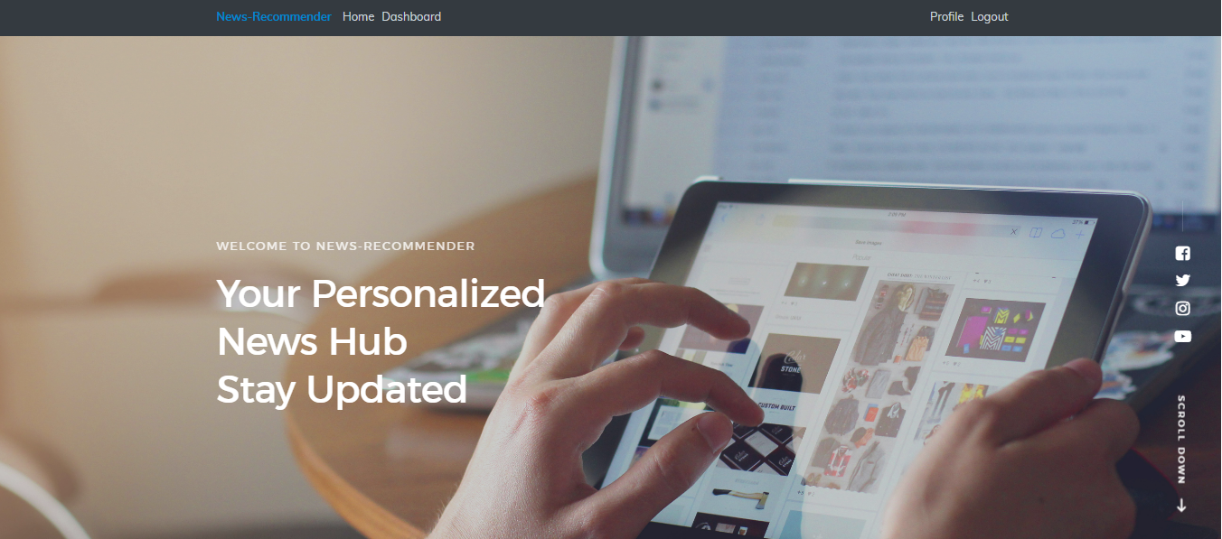

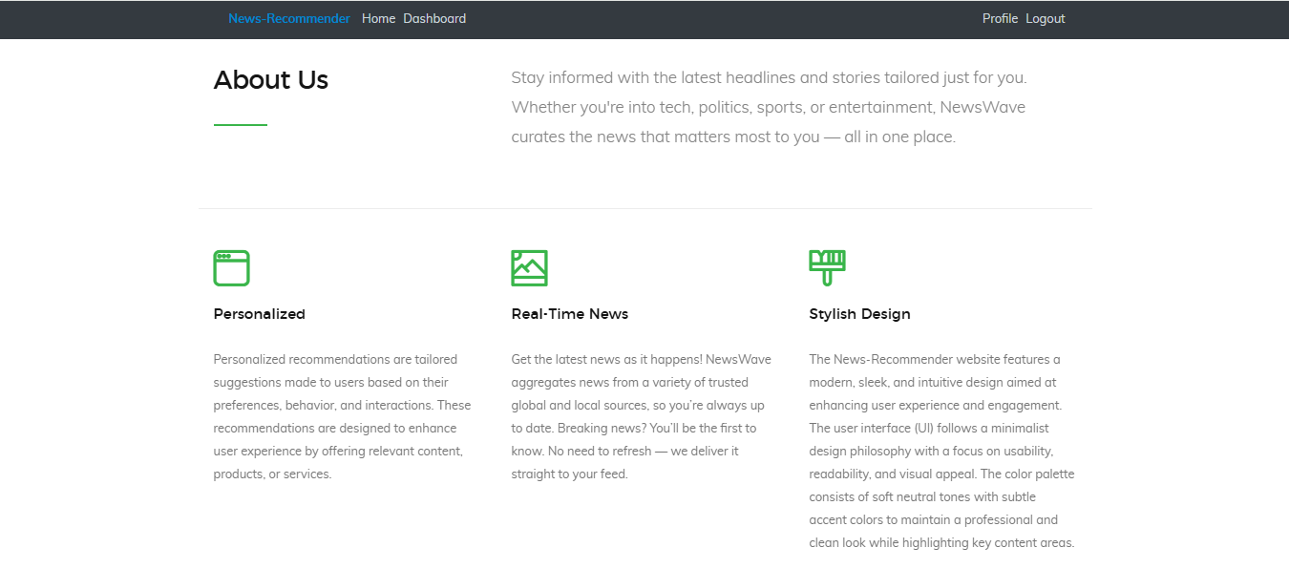

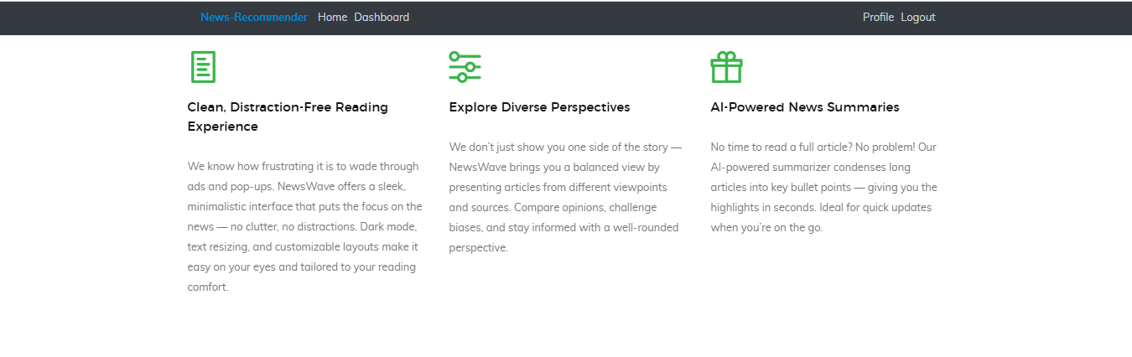

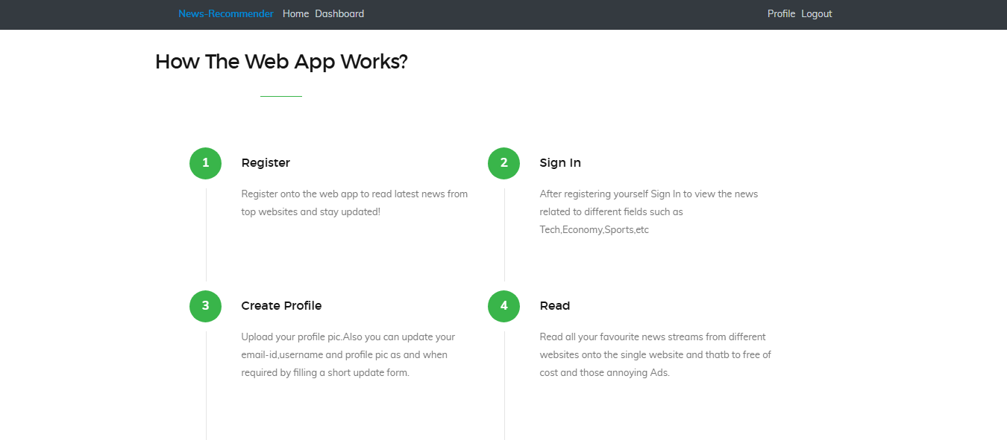

**Registration Section**

This section allows the user to sign in into the application, the user is prompted to input their username, email, and password. Various checks have been done under each sub section to ensure that the information inputs the corrects details hence ensuring accuracy and consistency.

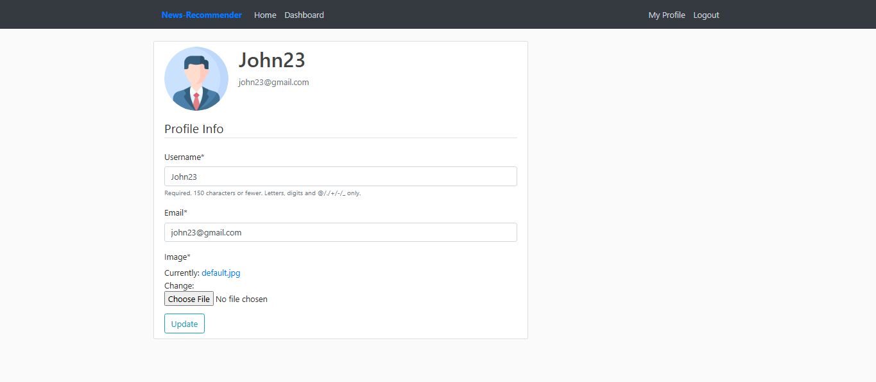

Once logged in, a user can navigate to their profile section to confirm their details, and make relevant updates with regards to the same.

**Bubble Filtering and Echo Chambers**

The News Recommendation system has made use of bubble filtering to remove the data that does not align with the needs of the user hence enabling us to only work with the relevant data set that can be used, this will therefore allow the user to view the content that matches their needs. This has been leveraged through the Scrappy web crawler whereby after we scraped the data we removed the irrelevant data like advertisement, this will in turn allow the user to only view the clean information that matches their preference. A priority is given to the relevant data whereby we were only focusing on the key areas of the news like the title, image, the body of the scraped news, and the date of publication to allow the user to only view the news that are up to date. This has helped us in reducing redundancies and separating the clean data from large pool of data.

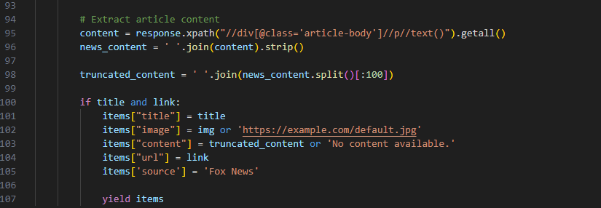

Our System has implemented Bubble filters through the removal of news content that does not meet the needs of the user which can be in the form of advertisements. The system further places a priority for specific sections of the news during scraping hence in turn aiding in the avoidance of repetitive content, through the selectors in CSS we were only targeting specific web elements made through HTML.

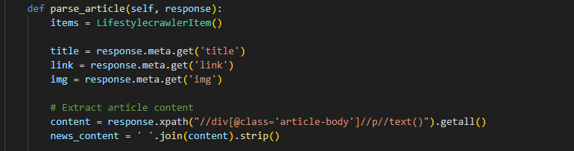

We leveraged on echo chambers by designing the system in such a manner that the target audience will only view the news that matches their current beliefs and knowledge hence removing information that might be perceived to disregard what they already know as facts. This will in return enable them to view content that is categorized and consistent to what they have been reading. This would further remove bias and enable the reader to find information that affirms with what they know.

**Recommendation Section**

This section enables the user to be able to select and personalize the information that interests them, the pool is diverse since it entails news from different sub areas like sports, politics, health, lifestyle, and entertainment.

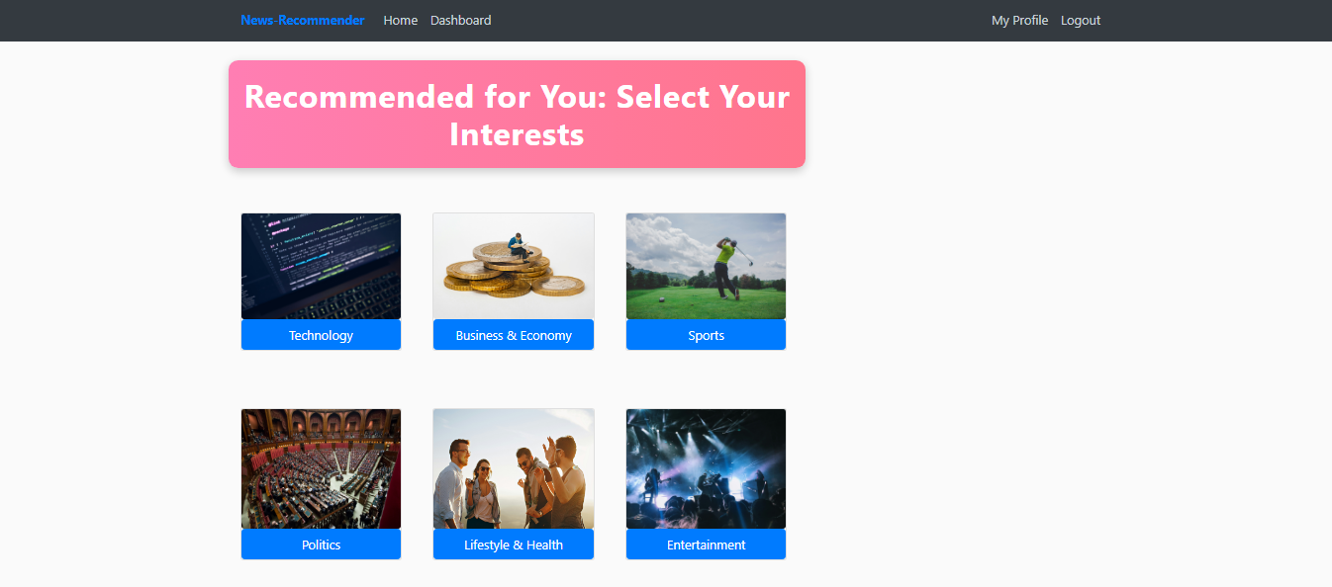

**Technology Section**

This section is made up of news that entail artificial intelligence and the emerging technological events, the user can navigate to this by clicking on the Technology button.



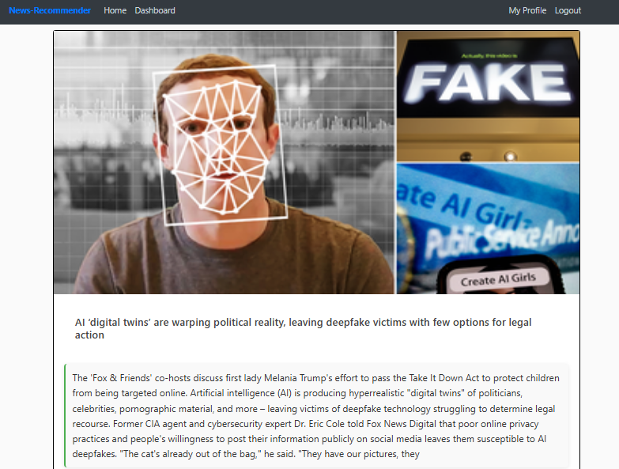

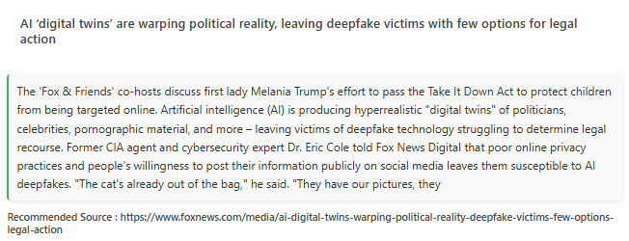

Based on the headline, the system will scrape and provide a relevant recommendation with regards to the same.

**Business and Economy**

This section provides recommendation on news that entails business and the current economic trends, for our case we scraped news from the fox website. Recommendations are further provided based on the headline; the user can check further by navigating on the uniform resource locator.

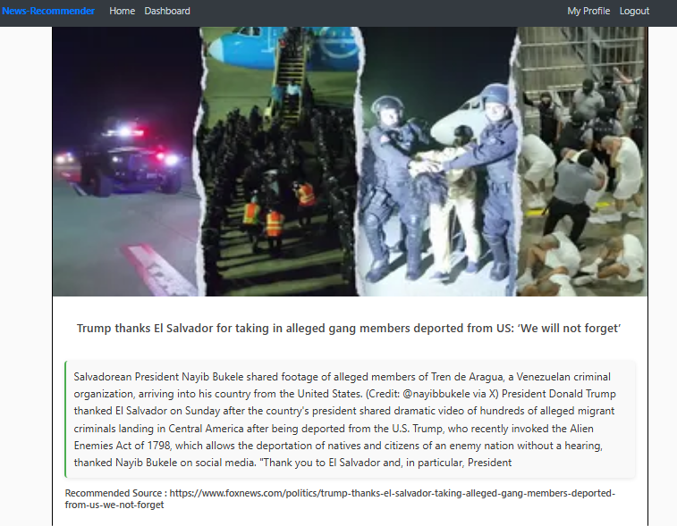

**Sports Section**

This section is made up a wide pool of news that are sports oriented, the user has a chance of navigating through each section and viewing the provided recommendation under each subsection.

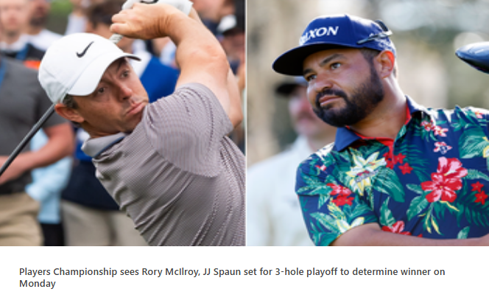

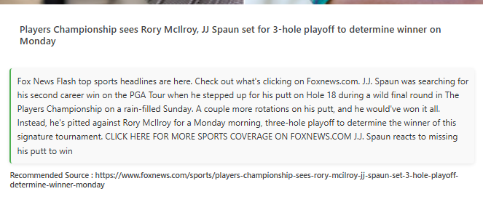

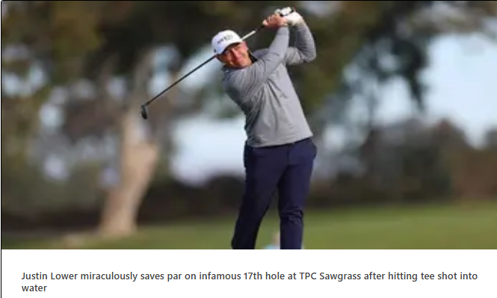

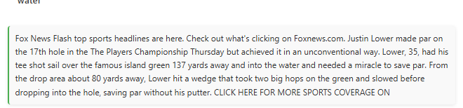



**Politics Section**

This sections presents news that revolve around politics, our dataset entails the political news that revolve around the United States, the system has grouped this similar section that is tailored towards the needs of the user.





**Lifestyle and Health**

This section is made up of news that entails the current trends of living, and the various health consideration for users. The crawler user has scraped from a wide range to enable the user have a diverse view of the emerging health trends.

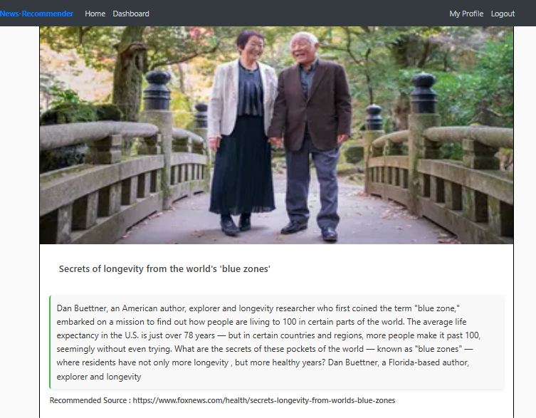

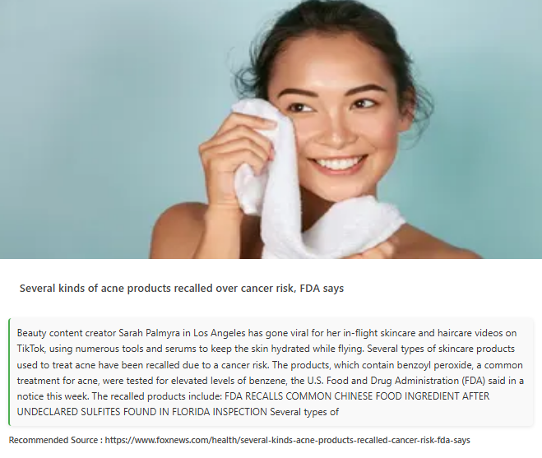

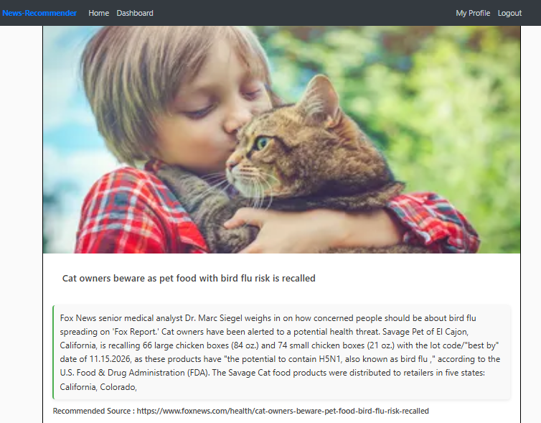

**Entertainment Section**

This section entails news that revolve around entertainment, the user can navigate through the various articles that having been suggested.

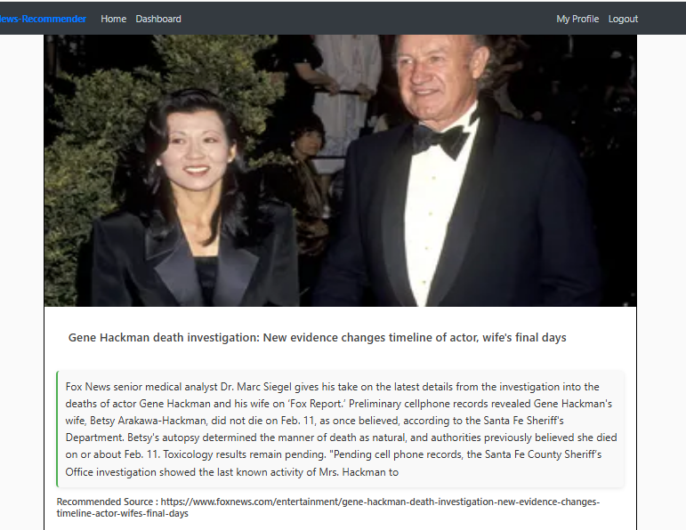

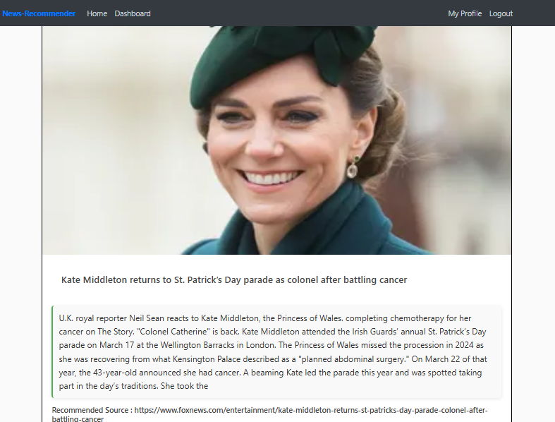

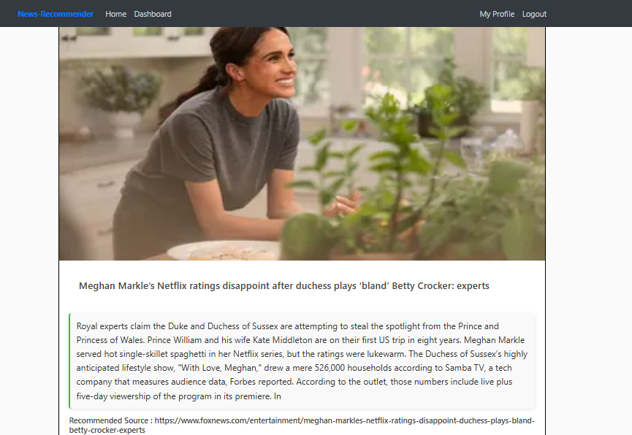

**GitHub Repository**

You can find our project under the following GitHub repository: https://github.com/Vignesh584/News_Recommendation/

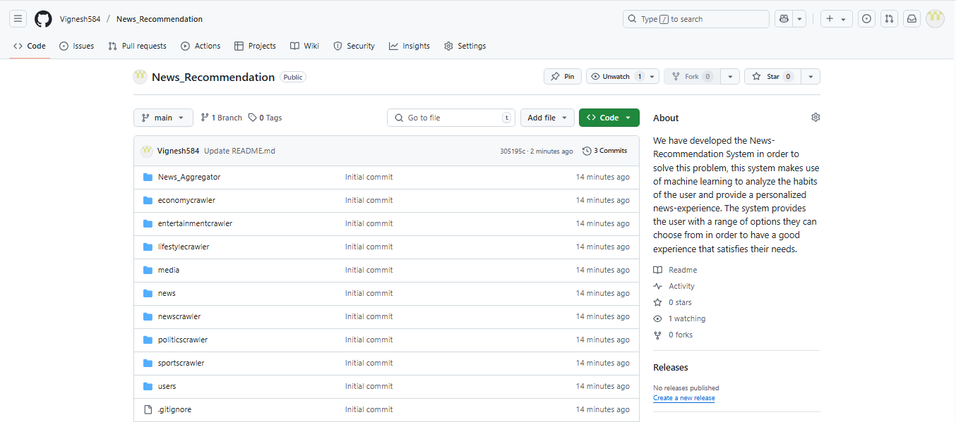

**Final Implementation**

The final implementation of the News-Recommendation system was done through Stream lit to allow for easy visualization. The following are the core interfaces of the system that were developed.

**Registration Page**

This section allows the users to create their profile, the user is prompted to input their username, email, and password which are later used for authentication.

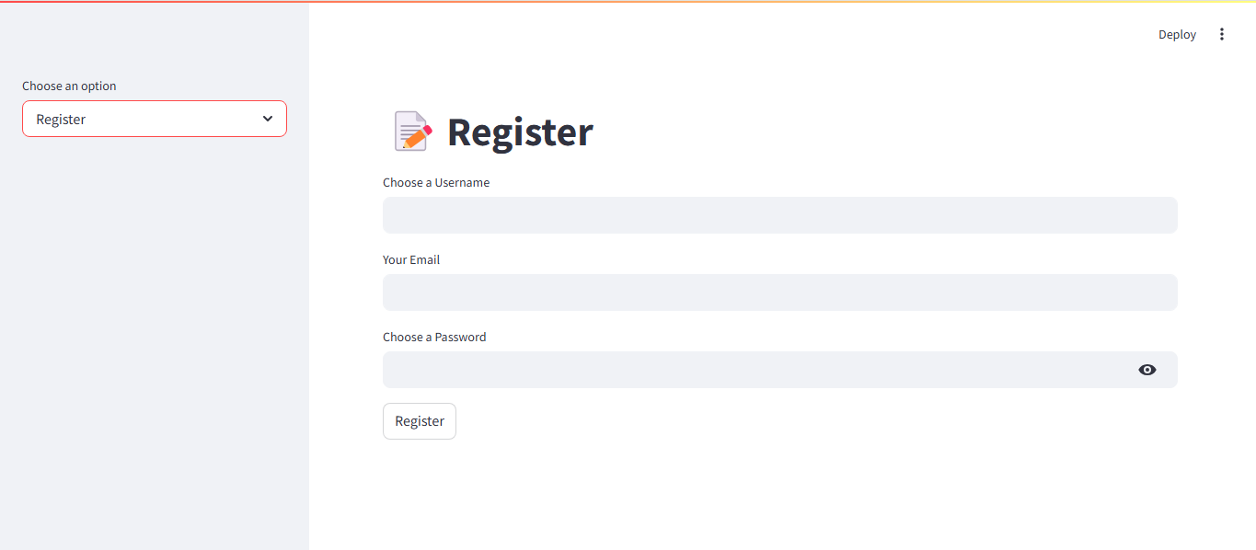

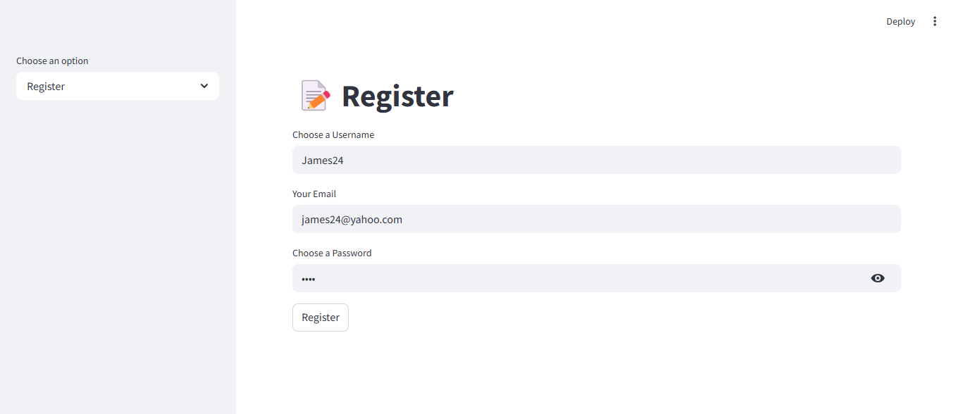

Once the user has entered their details, a success message will be displayed and the details stored in SQL lite database. The new user will then proceed to the login page in order to access the main page.

**Login Page**

This page authenticates the user and allows them to access the main news page, the user is required to input their username and password.

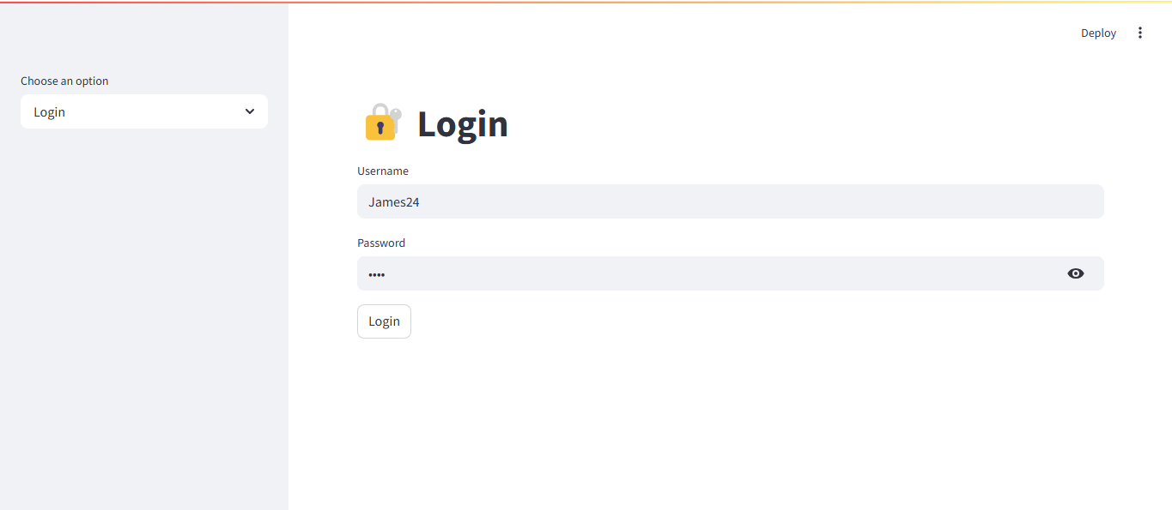

**Main Page**

Once logged in, the user is directed to the main page, this page is split into two sections, the news feed and the Profile section.

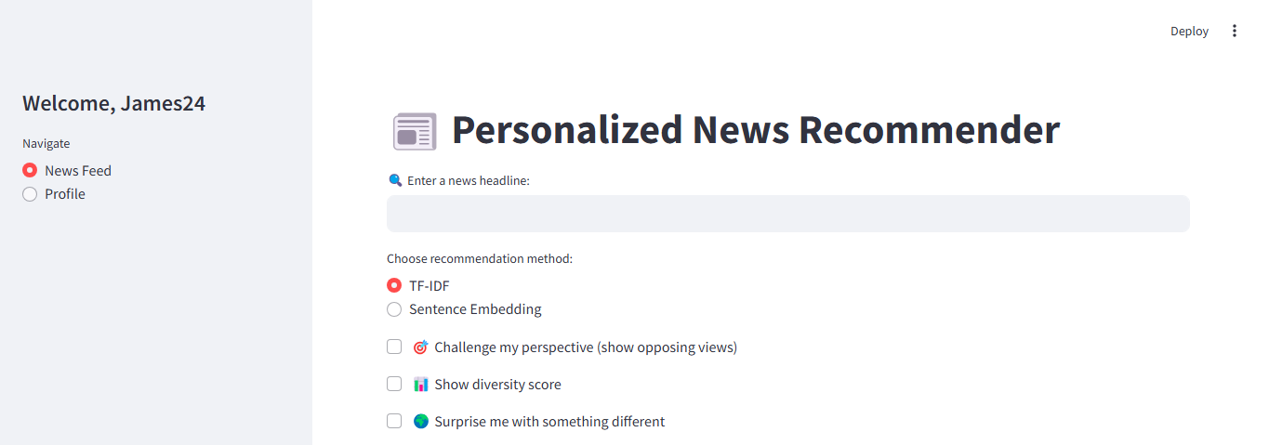

**News Feed**

This is the main page of the system; it allows the user to search for the relevant news articles, and provides relevant recommendations for the same. The user interacts with this section by entering a keyword or title of the news in the text box.

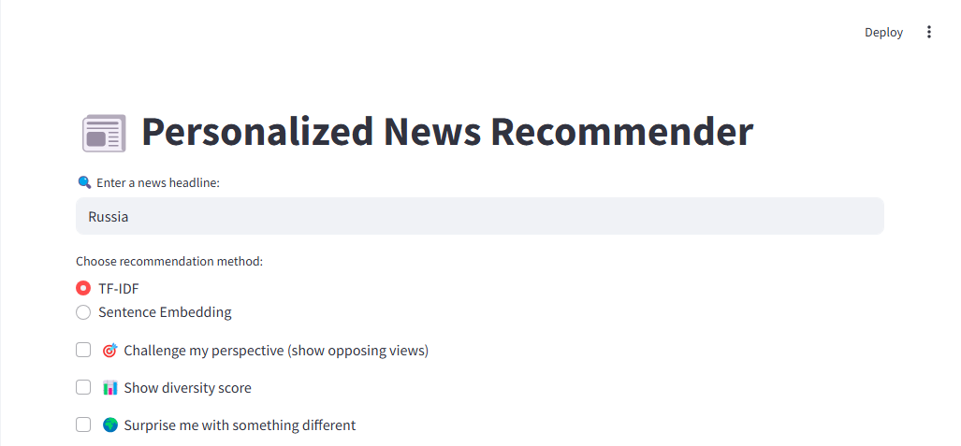

The system will then preprocess the user’s input by cleaning it and performing conversions into numerical format through the TF-IDF option. The system will further perform tokenization, applying lowercase, and removing stop words. A collection of news articles is loaded from the news.json file contained in the data folder. Each news article is characterized by fields like title, content, category, and the publication date.

The text of each news article is cleaned and changed into TF-IDF, this enables important information to be captured which is relevant to the full dataset. Cosine Similarity subjects the input of the user with the vector of each news article. A similarity score is used to measure the proximity of the query to the content of each news article.

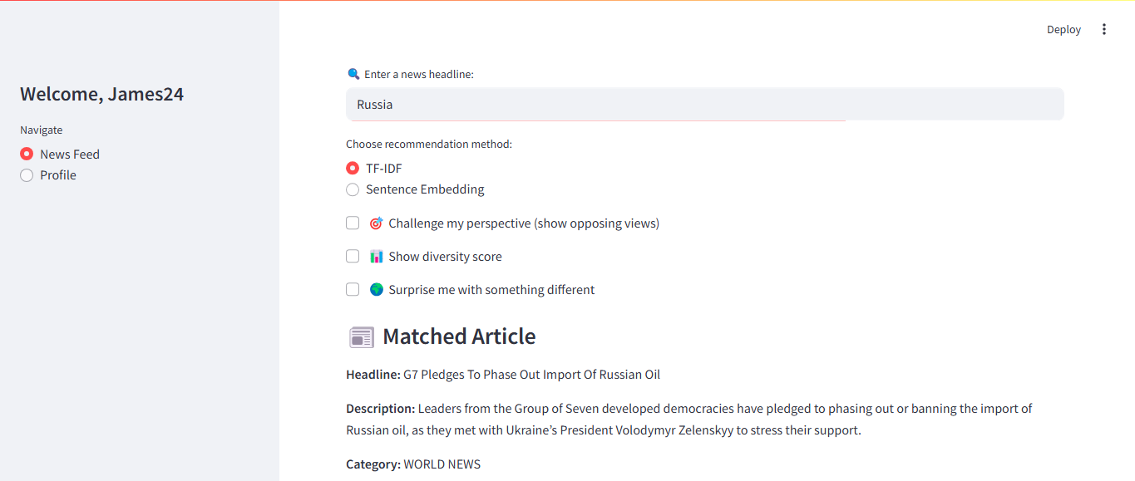

News articles are then sorted from the most relevant to the least relevant through the basis of their similarity score. Those articles which are recommended are displayed to the user with each characterized by the unique title and the URL link that the user can use to check the source.

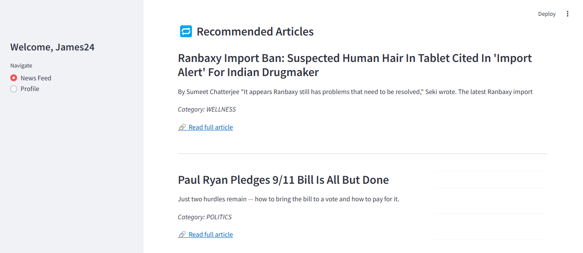

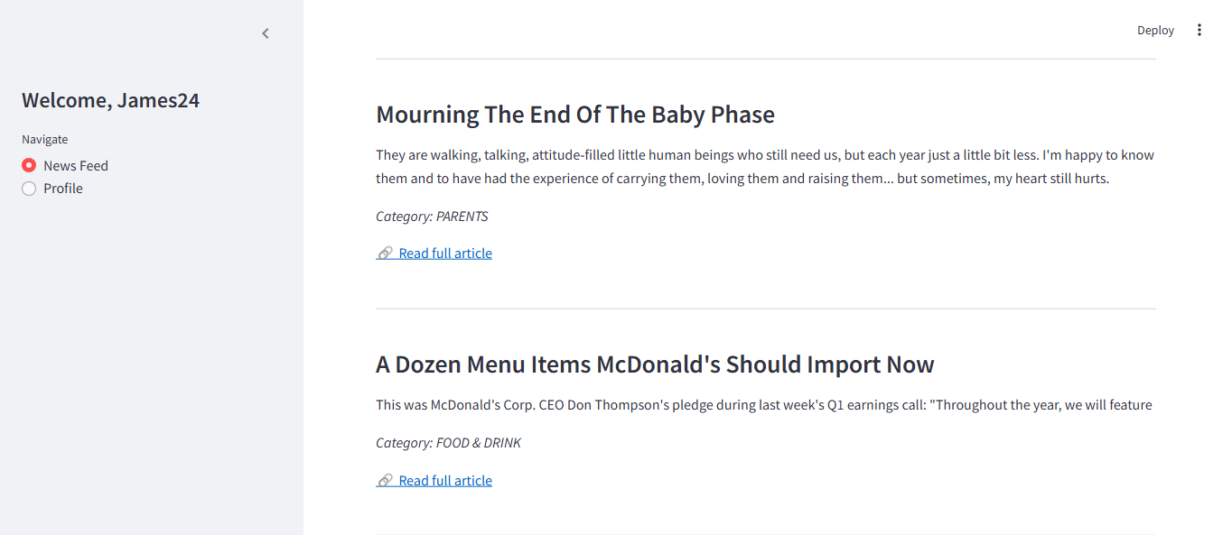

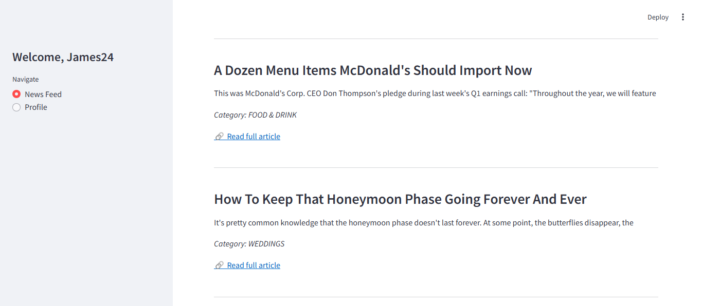

The user can further switch their selection method Sentence Embedding which offers a more contextual way of understanding and performing text comparison. It converts a sentence or paragraph into a fixed-numerical vector, this aids in capturing the meaning and not just individual words.

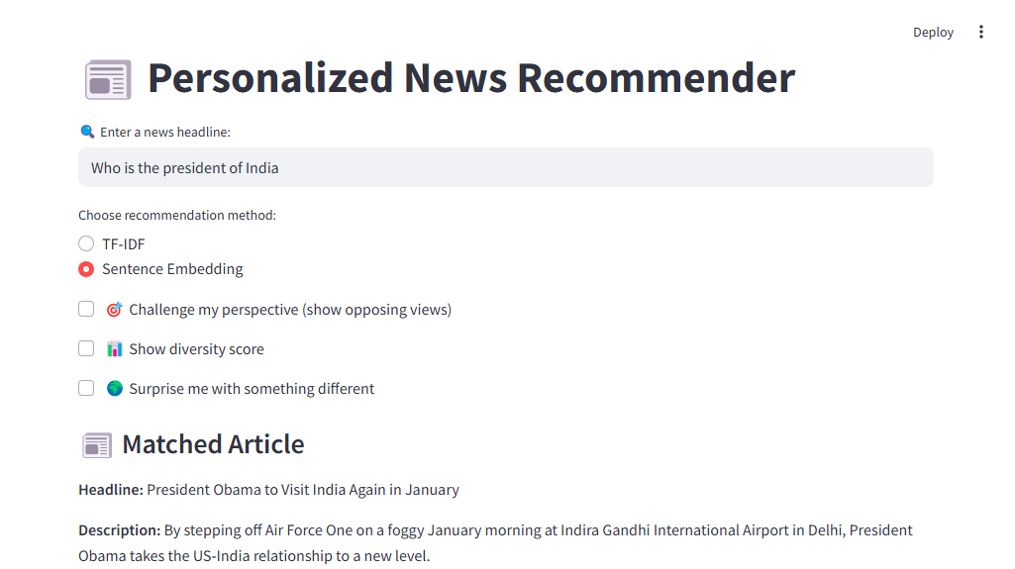

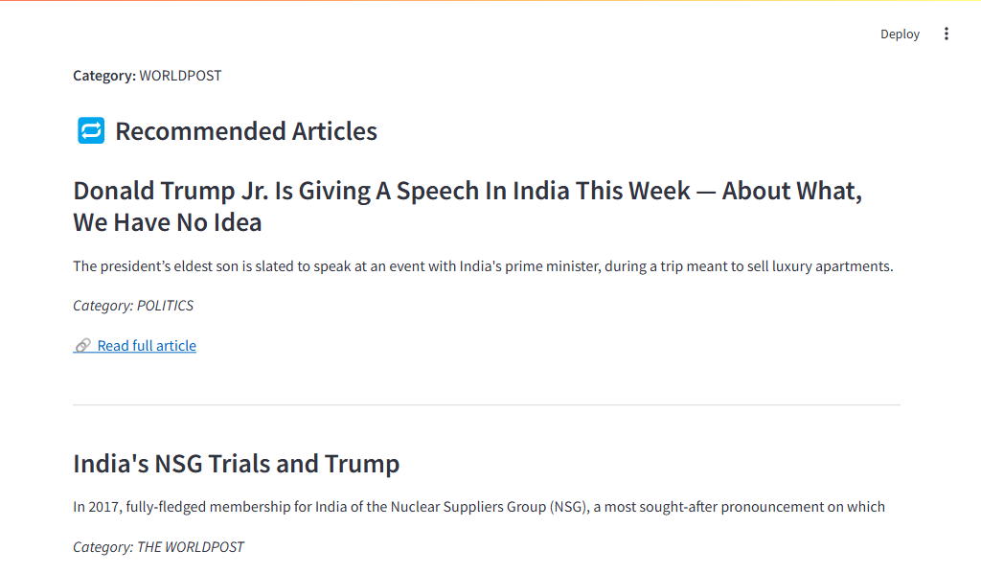

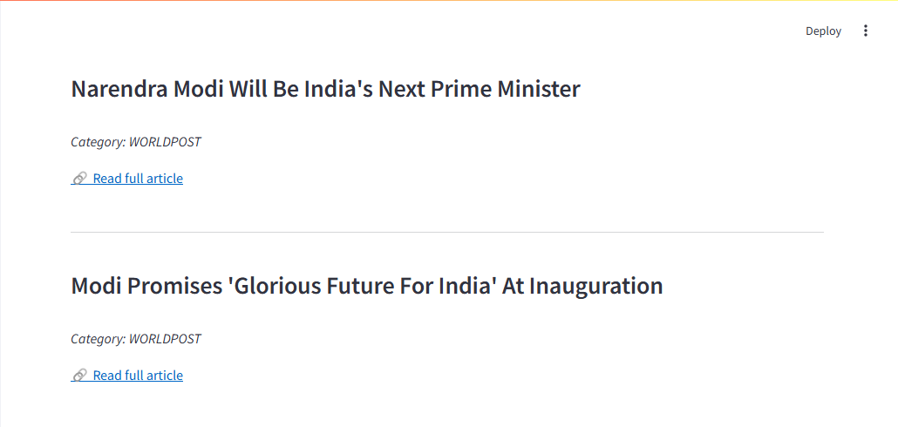

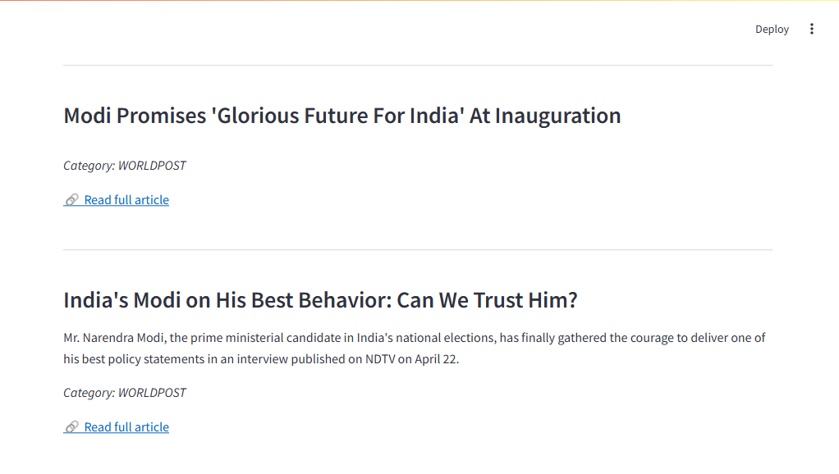

The system has been integrated with the news API that allows it to scrape the trending news in real time and display them, this enables the user to select their areas of interest, and enjoy the process.

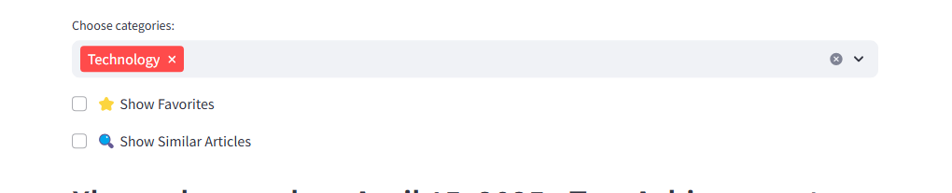

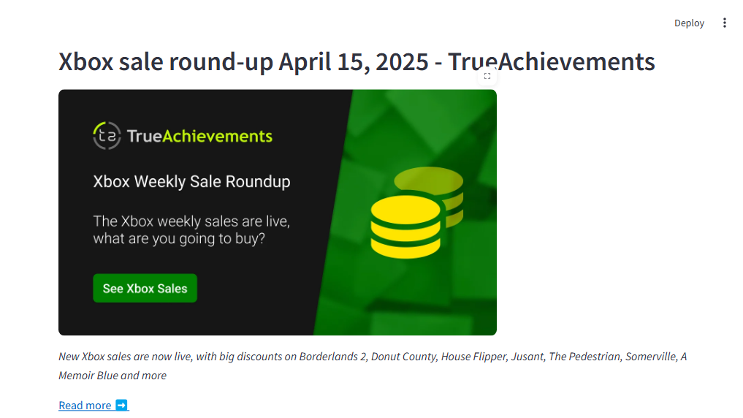

This allows the user to be able to react to news articles by liking or adding to favorites, this in turn aid in personalizing their content.

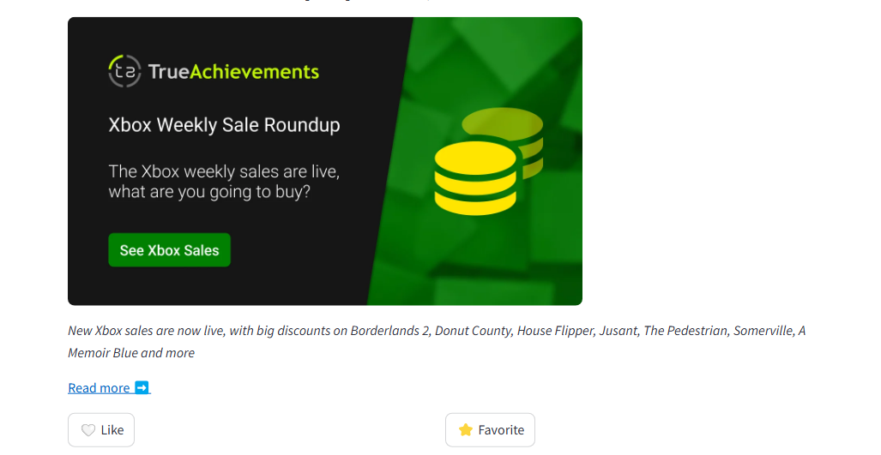





The user can traverse to their show favorite page that displays their personalized news content that is unique to each user.

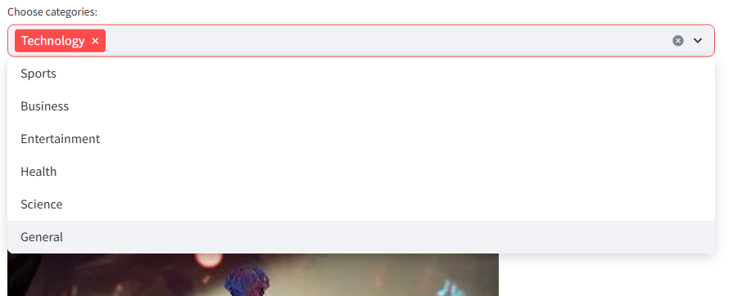

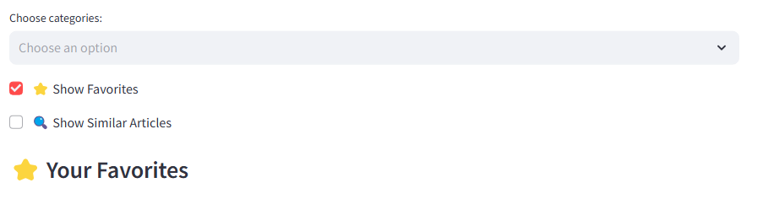

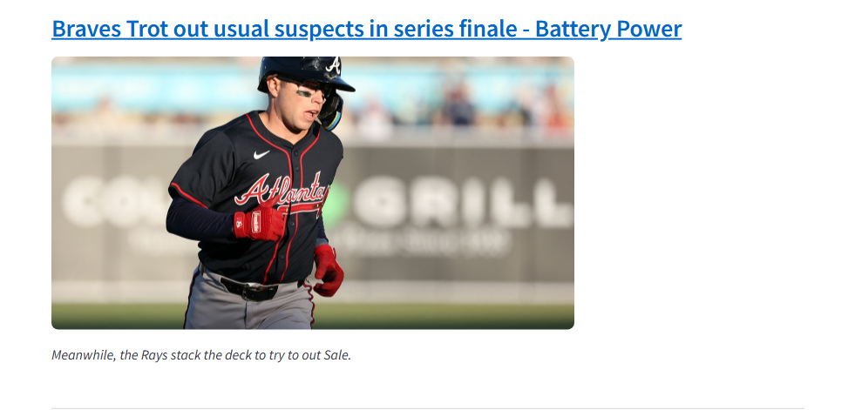

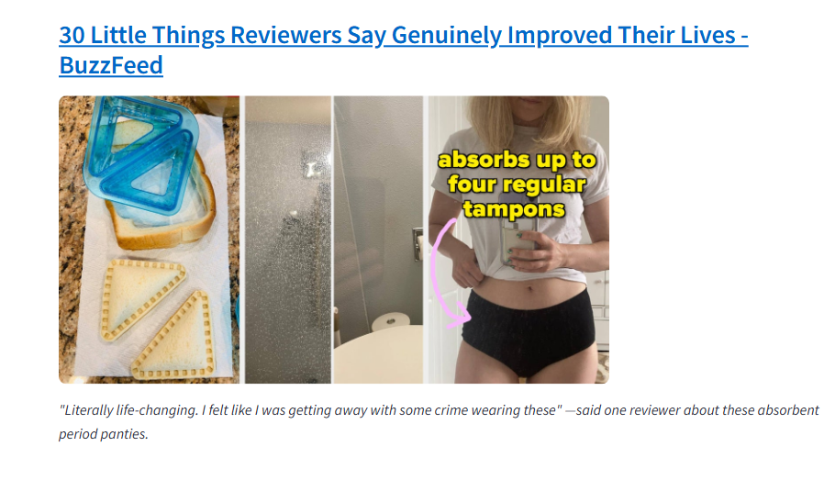

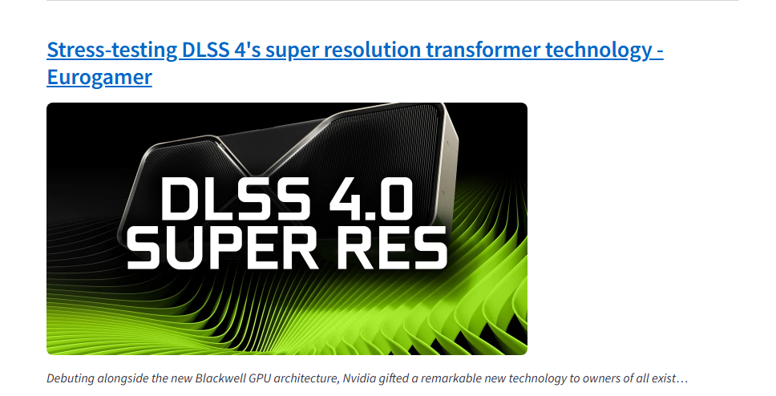

The show similar action provides a recommendation of the users articles and enables them to view other similar sites.

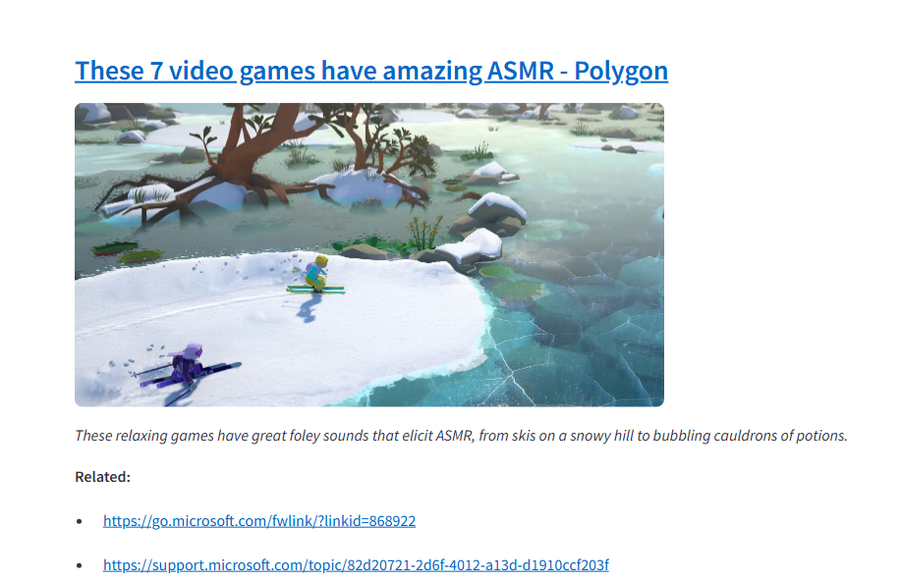

**Profile**

This section contains the details of the logged in user, it allows them to logout once they are done with their session.

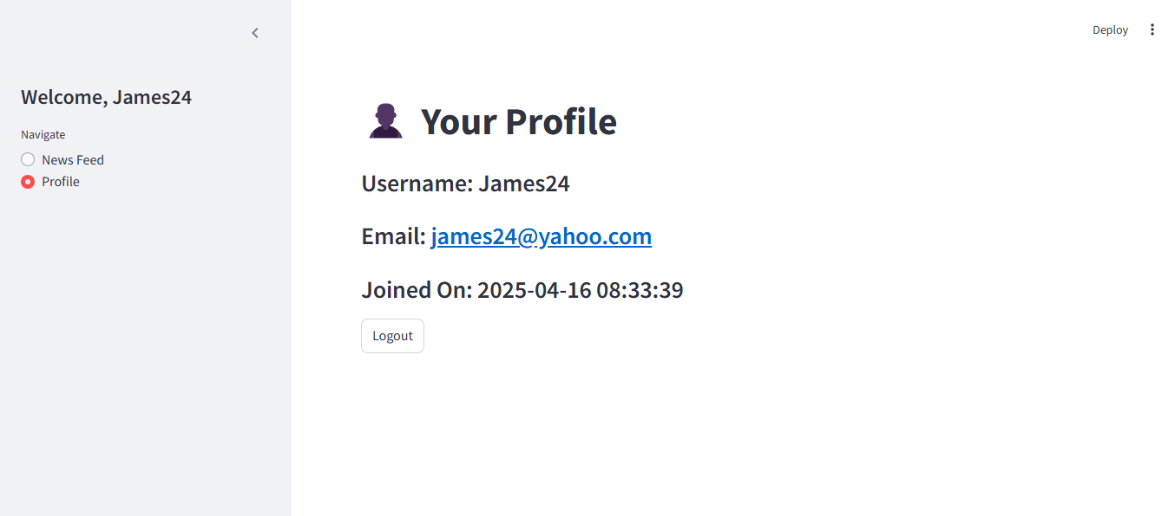

**Libraries and Frameworks**

The News-Recommendation System has leveraged a number of libraries which have been used in handling the different aspects for processing the data, machine learning, and the development of the user interface. The following libraries were used in the development of the system:

Python Surprise- This was used for building and evaluating the recommendation models basing on filtering techniques like the K-Nearest Neighbor

Scit-learn- This was used for processing the scraped data, classifying the data, perform clustering, and analyze the collected data through regression algorithm.

Natural Language Toolkit(NLTK)- This was used to tokenize the collected data, and add stop word for removal.

Scrapy - This was used for scraping the news information from the Fox website, the scraped data included the title, content, and the image.

Beautiful Soup – This was used for parsing the scraped data between the HTML document.

Python Django- This was used for building an interactive user interface that would enable the users to interact with the system.

SQLite – This was used to store the information that pertains the user, their preferences, and recommendations.

**Individual Contribution**

Student 1:

I took part in the development of data handling for the system, I used the surprise library that acted as our filtering model, I further ensured that the model was accurate and relevant to the system. I also worked on the various pipelines that are used on the system to process data, I did this by leveraging Panda and Numpy to clean the data, remove inconsistencies, and encode it in the manner that could be understood by the model. I have used API endpoints on the backend, this have played a bigger role in handling the data collected from the user.

An important skill that I have gained while undertaking the project was on how I can be able to use Surprise library to implement and optimize collaborative filtering model. I have understood how to adjust parameters as a way of improving the consistencies and accuracy that is needed for the recommendations.

Student 2:

I was in charge of the front-end development and web scraping aspect of the system. I have leveraged on Django to build interfaces that are appealing and interactive hence ensuring that the system is user-friendly. I have enabled the users to be able to customize their feed by setting up dynamic filtering option, this helps to sort the news articles based on their time of release. I made use of Scrapy web crawler and python Beautiful soup library to obtain data from the fox website, this data would then be stored in SQLite in a structured manner. My major responsibility was to ensure that the data which had been scraped was clean and accurate.

The useful skill that I have learned is how to perform web scraping efficiently through the use of the Scrapy web crawler and how to integrate the different document object models.